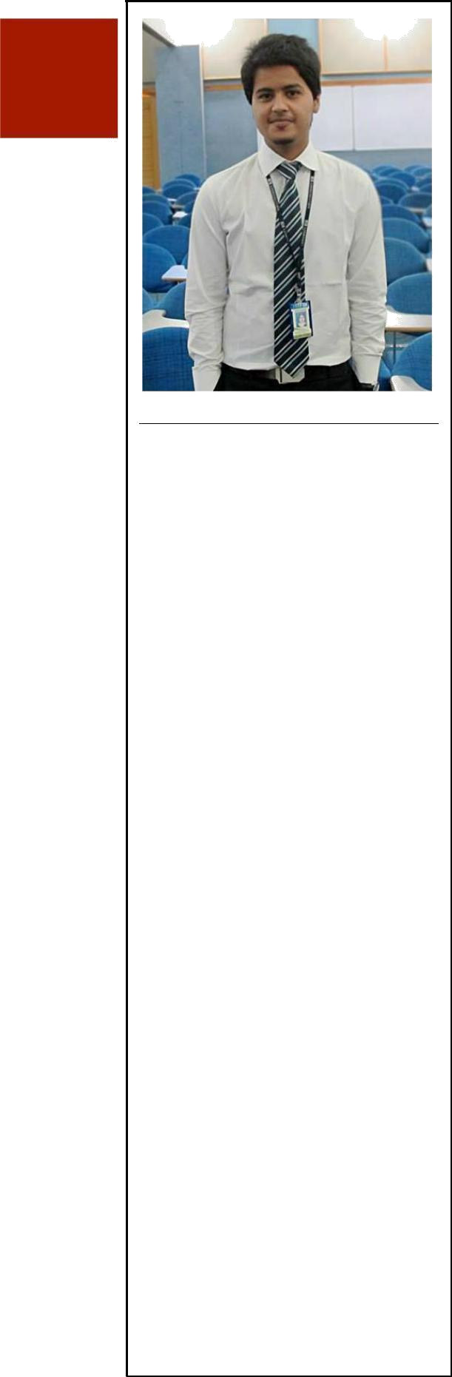

- E R S O N A L

House No. N-163, block 12,

Gulistan-e-Jauhar Karachi.

+92-314-2862505

sadaanikram@yahoo.com

Date of Birth

1st November, 1993

Father’s Name:

(Late) MUHAMMAD AZAM IKRAM

- I E L D S O F I N T E R E S T

 Marketing

Sales

 Supply Chain
Management

- E R S O N A L S T A T E M E N T

-Make yourself to overcome by your sorrows they are the biggest flaw that leads towards failure.

-Your start doesn’t matter what matters is where you ended up.
SADAAN IKRAM

OBJECTIVE:

To accept challenges and make them accomplished. To invest my skills and proficiency in an organization and earn more skills of contemporary marketing trends.

EXPERIENCE


Senior Sales Executive, Auction House Japan.

Karachi — October, 2017 to June, 2018.

Officer Grade 2, Bank Al-Habib Limited.

Karachi — April, 2017 to October, 2017.


HR Corporate Training Intern, Pakistan Petroleum Limited.

Karachi — Mar, 2017 to April, 2017.

HR Trainee, Liberty Books Pvt. Ltd.

Karachi — 10 October, 2016 to 10 March, 2017


Senior Sale Executive, SBT Japan.

Karachi — 27 September, 2014 to 1 October, 2016

- 240% Profit Target Achiever.

Young Leader Conference, School of Leadership

Hyderabad — May, 2012

- Able to make conference happen as best as it could be first time in Hyderabad.
EDUCATION
IQRA UNIVERSITY

Masters’ in Business Administration — June, 2016 to Dec, 2017 (Marketing)

IQRA UNIVERSITY

Bachelors of Business Administration (Hons) — August, 2012 to May, 2016 (3.01 CGPA)

ARMY PUBLIC SCHOOL & COLLEGE SYSTEM

Intermediate (Pre-Engineering) — August, 2011 to May, 2012 (A1 Grade)
SKILLS

- Knows URDU, ENGLISH and SINDHI
- Human Resource Utilization

- Talent Recognition
- Quick learning / Adaptation / Dynamic

- Emotional Intelligence

- Effective Communication Skills. (Done 2 courses, OC. & BC.)

- Convincing Skills. (Collaborating schools with 1rs. schoolproject)

- Professional Presentation Skills. (Numerous class presentations)

- MS Office (Excel, Word, PowerPoint)
EXTRA CURRICULAR ACTIVITIES

- Research articles (3 psychology research papers & 4 management issue based cases)

- Attending Conferences (Future of Marketers, Necessity of HR in an Organization)

- Photography

- Playing Basketball (Ex-Junior Coach at BISE Hyderabad)

