Muhammad Asims Zulfiqar  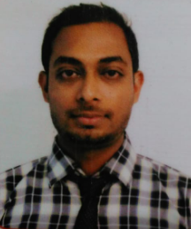  CONTACT  Address:  R-428 Sector 15- B Buffer zone North Karachi  Phone:  +923432481947  Email:  asimzulfiqar7@gmail.com  LANGUAGES  Spanish – Learner  English – professional |  | OBJECTIVE  To secure a challenging position in a reputable organization to expand my learnings, knowledge, and skills. Secure a responsible career opportunity to fully utilize my training and skills, while making a significant contribution to the success of the company.  WORK EXPERIENCE  09/2012 to 06/2014  Customer service representative, UBL BANK LTD,  Responsibilities:  - Resolve customer problem regarding transaction and activating data on call.  - Prepare data and information for making regular report data analysis  - Be active on the call to to check the transaction which is requesting to be done by original person  - Activating customer credentials with full responsibility.  06/2015 to 06/2019  International Sales Executive at SBT JAPAN CO.LTD  Responsibilities:  - Auction buying  - Bidding on direct auction  - Buying and selling of car's Truck's and Suv'  - Strong grip on Auction  - Hanlding customer's and receiving car's payment with them  - Ability to sort those car’s on which customer backed off  - Good technical knowledge of car’s  - Knowledge of Auction’s houses  EDUCATION  Bachelor’s in Commerce from University of Karachi 2013  Intermediate in Commerce 2010  Matriculation with Science 2008  ADDITIONAL SKILLS  Microsoft Office Access  Ms Excel  REFERENCES  References available on request

